Ohio Department of Transportation

Ohio Contractors Association

Don Conaway Partnering Award

2019 Nomination

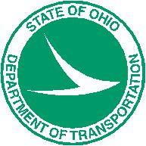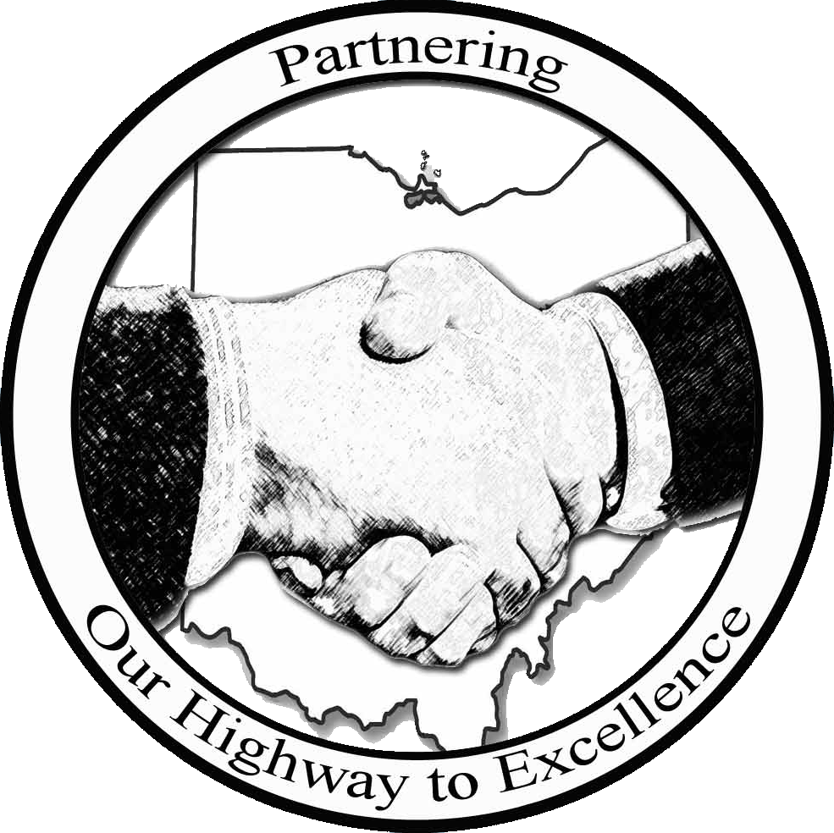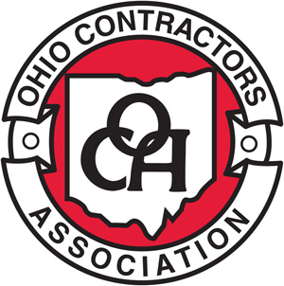

Nomination Deadline: Friday, January 4th, 2019

1980 West Broad Street
Columbus, Ohio 43223

www.dot.state.oh.us/pages/home.aspx

www.ohiocontractors.org/default.aspx

DON CONAWAY PARTNERING AWARD CATEGORIES

A project team, consisting of the Contractor and ODOT, will be recognized in each of the following project categories:
- Category 1 – (Under $10 Million)
- Category 2 – ($10 – $50 Million)
- Category 3 – (Over $50 Million)

2019 ELIGIBILITY REQUIREMENTS

- Projects must be substantially complete by Dec 31, 2018.
- All ODOT let construction projects are eligible.
- A project can only be nominated once for consideration of this Award.
- Projects must be nominated jointly by both the Prime Contractor and respective ODOT District.

AWARD PROGRAM GUIDELINES

Nomination Deadlines and Submittal Information
Nominations to be sent/ emailed to:
Chase Wells, ODOT Partnering Coordinator – by Friday, January 4th, 2019
1980 West Broad Street
Columbus, Ohio 43223
Mailstop 4090

For questions contact:
Chase Wells, 614-466-4789, Chase.Wells@dot.ohio.gov

Selection Criteria

  - Establishment and achievement of goals.
  - Management of Key Stakeholder relationships.
  - Subcontractor involvement in the Partnering Process.
  - Safety Record of the Project.
  - Challenges encountered and the means to overcome.
  - Utilization of the Dispute Resolution Process.
  - Mitigation Efforts to reduce the risk of claims.
  - Project completion On Time and within Budget.
  - Value Engineering Change Proposals.
  - Demonstration of Partnering Values.

Selection Process

The Don Conaway Partnering Award selection process is conducted by the ODOT OCA Partnering Steering Committee which is comprised of both ODOT Central Office and District, OCA, and Contractor members. The Committee oversees the award process and has final eligibility and award determination.

The Award recipients are recognized each year at the annual Don Conaway Conference.

The evaluation and selection process is as follows:

1. The ODOT Partnering Coordinator review submittals for eligibility and adherence to the requirements.

2. Committee reviews nominations against the criteria.

3. If necessary, a request may be made to the Project Team to present their project to the Committee to assist in Award determination during the evaluation process.

4. Selection of finalists for the Award for each project category.

5. Presentation of the Award at the annual Conaway Conference.

Note: Any Committee member who has a business relationship to a potential winner will be excused from participating in the determination of the award.

2019 Don Conaway Partnering Award Nomination

Nomination Form

To Check/Un-Check Boxes: Right Click on Box, Select Properties

Check only one project category below:
Category 3 ($500M and above)
Under $10 Million (Category 1)

$10 Million - $50 Million (Category 2)

Over $50 Million (Category 3)
Application Information

To Enter Info. into the Boxes: Right Click on Box, Select Properties, Type Info. into “Default Text.”

Project Number: Project Location (C-R-S):

Project Description

Note: Please provide any project photos along with this nomination form.

Team Members

(Please identify the ODOT Project Engineer, Prime Contractor, Designer, Subcontractors, and Partnering Facilitator)

- ODOT Project Engineer:

Telephone Number: Email:

- Prime Contractor:

Contact Name: Telephone Number: Title:

Email: Mailing Address:

- List names of all Sub-Contractors:

- Designer:

Title: Telephone Number: Email:

- Partnering Facilitator (if applicable):

Telephone Number: Email:

Project Data

Project Bid Date: Project Award Date:

Original Completion Date: Substantial Work Complete Date:

Original Project Bid Amount: Final Project Amount:

What goals were established and how were they achieved?

How were subcontractors and/or Key Stakeholders involved in the Partnering process and what role did they play in the success of the Project?

List any teambuilding activities or unique motivational activities utilized by the Project:

Safety Record of the Project:

Challenges or Obstacles encountered, and the means used to overcome?

# of Early Written Notice: # of Step 2 Disputes: # of Claims

If applicable, what mitigation efforts were taken either before or during the Dispute Resolution Process?

List the number and savings from the Value Engineering Change Proposals:

How did the project finish in relation to critical milestones?

How did the Project Team demonstrate that Partnering added Value to the Project?

List any Quality Awards the project has received (e.g. Smooth Pavement Award).

Please share any innovative ideas, lessons learned, or additional facts from the project that could provide insight in helping other teams improve their projects.

By submitting this application form, all materials become the property of ODOT’s Statewide Partnering Committee and may be used in education, marketing and promotion for the Don Conaway Conference.

Prime Contractor

Name:

Title:

Organization:

Phone:

Email:

ODOT District

Name:

Title:

Organization:

Phone:

Email:

When submitting project photos, please keep such separate from this nomination document or present in a manner that maintains quality and allows for ease of extraction. JPEG images are preferred, and photos will be used to present projects at the 2019 Conaway Conference. For submission questions, please contact Chase Wells at chase.wells@dot.ohio.gov or 614-466-4789.

